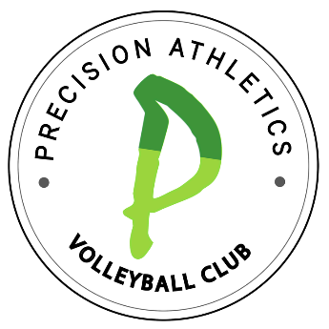
Committed to the success of our players.

- COPPER SPONSOR: $100
  - Mentioned in the Club Welcome Packet & Emails.
- BRONZE SPONSOR: $250
  - Mentioned in the Club Welcome Packet & Emails.
  - Logo on PAVC website.
- SILVER SPONSORSHIP: $500
  - Mentioned in the Club Welcome Packet & Emails.
  - Logo included on PAVC website.
  - Company name and logo on 2024 Summer Shirts (Must have money by May 31, 2024)
  - Recognition Plaque
- GOLD SPONSORSHIP: $750
  - Mentioned in the Club Welcome Packet & Emails.
  - Logo included on PAVC website.
  - Company name and logo on 2025 Winter & 2024 Summer Shirts (Must have money by May 31, 2024).
  - Recognition Plaque
  - Public recognition via club email (1000+ subscribers)
Yes, we would like to be a PAVC sponsor!!
Company Name: _______________________________________________________________
Contact Name: ________________________________________________________________
Mailing Address: _______________________________________________________________
City: ________________________________ State: __________ ZIP: ___________________
Phone: ___________________________ Email: _____________________________________
Website Address: ______________________________________________________________

Payment Method: Check __________ Credit ___________
Credit Card #: ______________________________ Exp Date: ____/_____/_____
3 Digit CVV # _________ (Required by our server)

Player/Referral: __________________________________

Please send all sponsor forms and payments to: PAVC, P.O. Box 1626, Mooresville, NC 28115
Please contact Cara Martin, Owner, at precisionathleticscmk@gmail.com.
Thank you for the support!!

